MELTON NEIGHBOURHOOD PLAN EXAMINER’S QUESTIONS
Joint response by Suffolk Coastal District Council and Melton Parish Council

- The adopted Local Plan runs to 2027 and the Neighbourhood Plan to 2030. Has a calculation been prepared of the housing number required for the additional 3 years? In view of the imminent review of the Local Plan and the uncertainties about future housing numbers beyond 2027 should the NP run concurrently with the adopted Local Plan?
Response:
A calculation has not been prepared of the housing number required for the additional three years of the neighbourhood plan as housing provision for the district post 2027 will be determined through the Local Plan Review both in terms of the overall numbers of homes to be provided and their distribution. This neighbourhood plan along with other lower order documents will however together provide for some 8,670 homes over the period 2010 – 2027 approximately 700 homes above the minimum set out in the Core Strategy. The Neighbourhood Plan is proposing housing in excess of that identified in policy SSP1 of the Site Allocations and Area Specific Policies Document for Melton.
A key piece of evidence which is underpinning the Local Plan Review is the Ipswich and Waveney Housing Market Areas Strategic Housing Market Assessment, published on 12th May 2017. This document identifies an objectively assessed need figure for the Ipswich housing market area and for the constituent authorities within it. These figures are set out in Table 8.1 which is reproduced below.
 | Dwellings per annum | Total dwellings | Market signals uplift (%) | Market signals uplift (dwellings) | Future jobs uplift  (dwellings) | OAN  (dwellings) | OAN  (dpa)
Ipswich | 472 | 10,382 | 10% | 1,038 | 838 | 11,420 | 519
Babergh | 309 | 6,799 | 15% | 1,020 | - | 7,820 | 355
Mid Suffolk | 411 | 9,046 | 10% | 905 | - | 9,951 | 452
Suffolk Coastal | 400 | 8,792 | 15% | 1,319 | - | 10,111 | 460
IHMA Total | 1,592 | 35,019 | 0.5 | 4,282 | 838 | 39,302 | 1,786

It will be seen from the Table above that the SHMA identifies an OAN for Suffolk Coastal District, of 460 dwellings per annum up to 2036. This figure includes a 15% uplift for market signals. The dwellings per annum (dpa) figure of 460 up to 2036 is a slightly lower annual figure than the 465dpa up to 2027 in the current Core Strategy.
The SHMA which will be used as the basis for the local plan reviews for Suffolk Coastal, Ipswich, Babergh and Mid Suffolk councils’. The aligned Issues and Options consultation for each of these authorities will commence on 18th August 2017. The availability of this document should therefore minimise any uncertainty with regard to future housing numbers beyond 2027. Paragraph 3.30 of the Core Strategy confirms that the updated OAN will be produced as part of the Review. It also confirms that that the OAN will have been updated using information from the 2011 Census and the performance of the local economy. The SHMA does this and follows the methodology set out in the National Planning Practice Guidance.
If a crude calculation were to be provided for the additional 3 years of the plan, then assuming that the requirement figure would be similar to that set out in SSP1 for the period 2010 – 2027, then the additional provision would be approximately 19 dwellings. The mixed use site proposal would more than meet this additional requirement. See also response to question 2.
For the above reasons, the Council does not consider it is necessary for the Neighbourhood Plan to run concurrently with the adopted Local Plan. This is not a matter which has been raised in respect of other, now “made” neighbourhood plans.

- Would you provide an estimate of the approximate housing numbers that are to be attributed to the former Council offices site and to the Cedar House site.
Response:
The Council are anticipating a planning application for the former Council offices site in the very near future and developer community engagement on scheme proposals has taken place earlier this year. This site is the subject or regular pre-application discussions between the site promoters and the Council. It is anticipated that the Council offices site will deliver approximately 100 homes. The Cedar House site has permission for 12 units in total.

- The final part of Policy MEL1 states that development proposals outside the physical limits boundary will not be permitted unless they relate to the site allocated in Policy MEL21. Would the QB explain what this point refers to as the site is shown as within the boundary.
Response:
This is an error with the mapping.

- The representation from Hopkins Homes (para 2.5) refers to planning permission for development of Woods Lane and proposals for the relocation of Woodbridge Town Football Club. Is the Woods Lane site that which has been granted permission on appeal for up to 180 homes or the adjacent site to the east? Please confirm that the site granted planning permission is within the Physical Limits Boundary. Are there any implications for the plan of the relocation of the football club?

Response:
The Woods Lane site is that which has been granted permission on appeal for up to 180 homes. SCDC would expect this site to be included within a revised physical limits boundary for Woodbridge.
Currently there are no specific or advanced proposals for a new location for Woodbridge Town Football Club. Any proposal would need to be considered against relevant policies in the Development Plan and any relevant emerging policies at the time. The football club is currently located within the parish of Martlesham on the edge of the built-up area for Woodbridge. Its existing site has been made available to the Council in a call for sites as part of early stages of the Local Plan Review. Were the football club to relocate, it would be expected that a range of alternative sites would be considered.

- The NP includes a number of proposals for new transport and community infrastructure. Would the QB set out a list of the prioritised infrastructure that is required to support the delivery of the development proposed in the NP as advised by the PPG. Would they identify separately those proposals that are considered to be community projects and aspirations to meet current deficits.
Response:
The Melton Neighbourhood Plan is not seeking to evidence highways capacity matters that relate to traffic movements beyond the parish scale rather than the scale of development planned in the neighbourhood plan. Many more aspirational infrastructure ideas put forward during the neighbourhood plan process than the key prospects included in the neighbourhood plan policies. The inclusion of particular highways and community infrastructure in neighbourhood plan policies facilitates opportunity to deliver such reasonable infrastructure prospects to enhance local quality of life with new development in the parish.

The village of Melton is located on a key crossroads in the district, the A1152 and the B1438 providing access to the A12, the main north south route for the district and to Woodbridge respectively from the Deben Peninsula and Rendlesham directions. The capacity of this local road network is already acting as a limiting factor to development in these wider areas. This is evidenced in policies SSP12, SSP13 and SSP24 in the Council’s Site Allocations and Area Specific Policies Document. The proposals for new transport provision including improved foot and cycle provision and car parking are therefore interlinked and, in some instances, extend beyond the boundary of the neighbourhood plan area. They also need to be considered in the context of the Air Quality Management Area at the Limekiln Quay/Thoroughfare junction in Woodbridge.

Improved foot and cycle path provision will help to provide alternative means of access other than by private motor vehicle to a number of facilities including the local schools and employment in and around Station Road in particular. This could help reduce the amount of vehicular traffic using the cross roads and accessing Woodbridge. The Parish Council would therefore be reluctant to prioritise individual proposals on the basis that given local circumstance it is preferable to maintain flexibility to allow schemes to come forward as and when opportunity allows given this wider (locally strategic) importance.

The Parish Council is also faced with a chicken and egg situation in that the District Council acknowledges that additional traffic modelling is likely to be required to help inform its Local Plan Review work which will need to look at the wider transport network across the district. If the Parish Council did not include support for a range of schemes to help improve the local situation within its neighbourhood plan this could be seen as not supporting improvements which may come forward through the Review process and not supporting strategic objectives.

It should also be pointed out that one of the conditions attached to the grant of planning permission for the Woods Lane development (appeal ref. APP/J3530/A/14/2225141) was that the existing footway on the northern side of Woods Lane should be widened, along with the provision of a Toucan crossing. In this respect, bullet point 2 of Policy MEL2 is already in the planning pipeline.

- Would the QB confirm that these projects identified in MEL2 have been agreed with the Highway Authority and are deliverable.
Response:
Suffolk County Council, in its representations, stated that Policy MEL2 is ‘generally appropriate’ and recommended amendments to the policy by SCC were made. Also, meetings were held between the QB and SCC as part of the development of the plan to review the deliverability of the schemes. Anything not considered to be deliverable was not included.

The work to identify the particular schemes was undertaken by a former Staffordshire County Council senior highways planner.

- Has an assessment been undertaken to show which routes will be affected by Policy MEL3?
Response:
A map showing the routes that will be affected has been included at Appendix A.

- Does the second part of Policy MEL6 on the loss of parking spaces apply only to residential development or to all forms of development?
Response:
This should correctly refer to all forms of development

- Has the QB prepared any evidence to demonstrate that Policy MEL7 is feasible and deliverable? Is the landowner supportive of the proposals?

Response:
MEL7 is an aspiration based on a great deal of feedback during the last 4 years of consultation with the community. Some way of retaining this area as part-greenspace and part-additional parking, to stop the people who currently park there unlawfully, would address the community’s wishes. It is also seen as part of the wider traffic management issues linked to the Woods Lane crossroads. This would be one of many projects that could potentially be paid for from CIL contributions and follows on from work that the Parish Council is doing to better manage the green area directly opposite where the village sign is. In this latter case the land is owned by Suffolk County Council Highways Department and after lengthy negotiation, the Parish Council has been given licence to put bollards up to stop people parking there. The MEL7 land is owned by Suffolk Coastal District Council and Melton Parish Council will engage with the District Council about working together to achieve something more beneficial for the community. Given how long it has taken just to get agreement for bollards on the opposite smaller piece of land we do not anticipate anything happening very fast, but it is certainly feasible. It was flagged many times by people during the NP process as an area that needed sorting out.

- Would the QB confirm that the proposal in Policy MEL9 can be undertaken without the loss of sports pitches, play space or protected trees so as to demonstrate that the proposal would not be in conflict with other safeguarding policies. Has a feasibility study of the proposal been undertaken to demonstrate that it is deliverable on the scale proposed?
Response:
Yes and also a feasibility study has been done. It is important to note that the project itself is being undertaken by the Parish Council and will itself be subject to continued public consultation, above and beyond the Melton NP. Detailed plans produced by architects Hoopers show that the proposals can be delivered without any impact on the football pitches, play area or tennis courts. All mature trees are covered by group TPO 25 and are unaffected by the proposals. Only 5% of the existing green space will be built on; however, the adjacent lower field will be reclaimed by drainage this summer, bringing back a large recreational area into use, so more than offsetting the small loss of green space. Also, the Suffolk Wildlife Trust (SWT) is proposing to open up their wildlife field immediately to the north of the playing field, with direct access, thus increasing the area available for public recreation even more. The facilities available within the play area are to be increased in the current financial year, and if the village hall is constructed it will have facilities for indoor sport and recreation. Hoopers have yet to liaise with Sport England (a statutory consultee on any formal planning application) but this is expected to be done shortly. A copy of the plans and cost estimate which was subject to public consultation in early 2017 is attached as Appendix B to this response.

- Has any evidence been undertaken to demonstrate that the proposals in Policy MEL10 are feasible as part of the development at Wilford Bridge Road? Would they be deliverable in the area at risk of flooding on the Wilbur Bridge Road site? Have any alternative site options been considered?
Response:
Detailed feasibility work has not yet been carried out and is intended to be undertaken as part of a planning application. Allotments and orchards for the community do not have to take up huge amounts of space and this can be incorporated with the farm as well as combined with the space they already have on Saddlemakers Lane. As the plan at the start of Section 10 of the Neighbourhood Plan shows, there would be approximately two hectares of green space available for such uses, which is considered to be significant and sufficient. Alternative sites have been extensively looked at and discounted by Pitstop and those who run the current Community Farm site on Saddlemakers Lane. They are keen to get the space at Wilford Bridge Road and have already discussed this with the developer. The Director of the Deben Community Farm has confirmed:
“Deben Community Farm Community Interest Company currently operates off Saddlemakers Lane, Melton. Prior to taking on a 20 year lease for this site we very actively engaged with numerous landowners in and around Melton to find a suitable site that met our needs for a Community Farm. Options were very limited until this site was offered which is ideal for easy access and the size of the land. We have also shown keen interest in becoming part of the possible Riduna site off Wilford Bridge Road. We have suggested we could also operate further elements of the Community Farm at this site. There is higher land to the rear of the site (out of the flood plain) and the potential to operate a small farm. We also run the Pitstop childrens club in Melton and are pleased that Pitstop makes local use of the existing farm, either for Forest Schools visits or during school half terms. There may be the potential to operate in a similar way at the Riduna site. I also confirm that these are the only 2 sites in Melton that we have active or future interests in.”

- National planning policy has moved away from defining Special Landscape Areas to defining Landscape Character Areas through Landscape Character Assessment. Has a Landscape Character Assessment been undertaken for the parish? If not, what evidence has been used to justify the definition of the boundary of the Special Landscape Area under MEL11? Would the QB supply me with the background evidence report.
Response:
Special Landscape Areas are a county wide designation to which strategic policy SP15 applies. The District Council has confirmed that that a decision as to whether to retain the SLA designation or switch to a landscape character area type approach will be a matter for the local plan review which will look at this topic on a district wide basis. The Parish Council has therefore not undertaken its own landscape character assessment but will expect to work with the District Council as part of this wider review. This is the same approach that the District Council has adopted with its own site allocations documents. Working with the District Council through the local plan review will enable a consistent approach to be adopted across the district. The NP retains the SLA boundary designation from the old Suffolk Coastal Local Plan (saved policy).

- The Site Allocations DPD states that a review of the SLA should be on a county wide basis. Do the LPA consider it appropriate for a review to be undertaken as part of the NP and have they provided any guidance on the review?
Response:
Special Landscape Areas are a county wide designation to which strategic policy SP15 applies. Whether to retain this designation or switch to a landscape character area type approach is a matter for the local plan review as it is a district wide (and wider than district) approach which needs to be looked at. The Council would not encourage a review as part of a NP preferring instead that a district wide approach can be agreed for the sake of consistency. The suggested change from SLA to a landscape character type approach will be included within the Local Plan review Issues and Options consultation document.

- Would the QB explain the implications of the SLA designation on the site allocation at MEL21. Has an assessment be undertaken of the landscape and habitats on the Wilford Bridge Road site? What mitigation measures are proposed in order to retain the important natural features of the site if it were to be developed for housing?
Response:

It should be noted that the plan for this combined area of development would mean that almost two-thirds of the site remains green in some way. There is a huge ‘flood compensation’ lake, a large area of recreational green space, the community farm, allotments at the top of the site above the houses, play spaces, gardens and trees and green gaps with a low density of buildings. Currently the site is partly covered in concrete and partly scrub land with no management or care. The two-thirds land remaining green or ‘undeveloped’ will allow the wildlife there to remain and the area will become vastly more attractive than it is currently. It will also allow the people of Melton to enjoy this area for picnics, boating on the lake, walking, cycling, gardening and play and to appreciate the natural features which will be retained.
Plans showing the proposed layouts and areas are included at Appendix C. The SLA designation has been taken very carefully into account in the design of the proposed scheme because it provides so many of the assets of the site as described above. Also though, the designation itself does not prevent development; it just has to be ensured that it does not have a detrimental impact on the designated area and its landscape assets. It is considered that the proposals in Appendix C demonstrate that this will be possible. Many of the issues relating to protection of habitats were addressed through the development of the Habitats Regulations Assessment (December 2016) which was one of the suite of documents submitted at the Regulation 16 Submission Stage (following the conclusions in the HRA screening determination which concluded that further work was necessary – including on the Wilford Bridge Road allocation).

- It is considered that the proposals for a new community hall under MEL9 would be in conflict with Green Belt Policy if the playing fields were designated as Local Green Space. To resolve the conflict between the two policies, it is suggested that the Playing Fields be designated as a “Safeguarded Open Space” and be subject to the last two bullet points of Policy MEL12. Alternatively, if the area of the MEL9 proposals is known, this area could be removed from the area designated as Local Green Space. Would the QB confirm which option is preferred.
Response:
The Parish Council consider that the former is the better option, i.e. designating the playing fields as ‘safeguarded open space’.

- The area shown under Policy MEL13 is substantially developed as a residential area. It is not clear which areas are to be protected from further development. There are a few mature trees within the area and several along the boundaries of the area. Elsewhere trees are mainly ornamental garden trees. Are the mature trees protected by tree preservation orders?
Response:
Although well developed, it is next to the playing field and the woods and still has a rural character. The point is to protect the trees and remaining green still there which, whilst a small area, is considered to be of significance. Within the area covered by Policy MEL13 there are substantial areas of woodland, some owned by MPC (Burkes Wood), some by SCDC, and some in private hands. All the woodland trees are covered by TPO 25 – Leeks Hill - made on 12 March 1953 by the former East Suffolk County Council. The list of TPO’s is very simple – just TPO 25, which refers to individual specimens and groups in the schedule..
If the Examiner is minded to delete Policy MEL13, then it is requested that at additional bullet point is added to Policy MEL18 (Character Areas) ensuring that greenness and openness is retained where existing, particularly with respect to existing natural features and open spaces’

- It is acknowledged that Policy MEL14 seeks to incorporate the principle set out in Saved Policy AP249. However, it is considered that the wording of the policy is unclear. Would you provide a definition of “riverside development” – does this relate to housing development and/or boatyards, moorings and sailing facilities? Are there any circumstances where such development could occur eg the redevelopment of existing premises? Would you confirm that the area shown on the Proposals Map is the same area as that covered by Policy AP249.
Response:
Riverside development, as we define it, relates to that development which by its nature requires to be located at a riverside location such as boatyards, moorings or sailing facilities. As such, it does not include residential development. Development of existing premises for riverside uses would be acceptable, provided it does not materially increase the level of built development on the footprint of the site.
It is confirmed that the area shown on the Proposals Map is the same as that covered by Policy AP249.

- Saved Policy AP241 on houseboats has been deleted under the Site Allocations DPD. Is there a strategic policy relevant to Policy MEL15 concerning such houseboats?
Response:
There is no specific strategic policy relating to houseboats. Policy SP3 is the generic policy which relates to new homes. Policy SP15 is relevant in relation to the Deben Estuary and its landscape and nature conservation interest designations.

- Has any assessment of the character of the areas to be protected under Policy MEL17 been undertaken? If not, then what are the reasons to justify identifying these areas for safeguarding? A restrictive policy such as this can only be accepted where there is robust evidence to justify it. What type of development would be acceptable in these areas; would any development greater than modest extensions be considered acceptable? Melton Grange site – would it be more appropriate to reduce the area to the open area in front of the Melton Grange in view of the development that has taken place around the Grange? Would it be more appropriate to include Burkes Wood as Local Green Space as it is comparable to the Hospital Grove Woodland? In which case would the QB undertake an assessment of the area against the criteria set out in NPPF paragraph 77.
Response:
The area is included as part of the Melton Grange Character Area (see Character Area map on p54 of the Neighbourhood Plan).
It is agreed that an appropriate approach for the Burke’s Wood part of the designated area would be instead to designate it as a Local Green Space under Policy MEL12. Appendix D contains a map showing the extent of the area along with justification for its designation under the NPPF criteria in paragraph 77.

- It is noted that the Site Allocations DPD does not identify the site between Wilford Bridge Road and Dock Lane as a general employment site. Are there any strategic policies that set out criteria that have to be met in order for sites to be identified as a general employment site? There do not appear to be any other proposals for the use of this area in the Local Plan. Policy MEL19 proposes that the use of the area should be limited to B1, B2, and B8 uses, however there is currently a number of other uses within the area. Should the type of uses be broadened so as to be more flexible. Would the QB comment on the suggestion to include “employment uses where it is demonstrated that there is no other appropriate location and the development will not involve a sensitive use that would impact on the operation of an existing employer”?
Response:
It is considered that the suggestion of broadening the permitted type of uses in this area is a reasonable one. The suggested text is supported.

- Development on the Deben Mill site is approaching completion. Is there any reason for including Policy MEL20 in the NP in the circumstances?
Response:
To cover any future redevelopment.

- Has an assessment of alternative sites be carried out to support the allocation of land under Policy MEL21 as required by PPG (paragraph 41-042-20140306). I consider that the alternative option stated in the Sustainability Appraisal of not allocating the site does not meet this requirement. Paragraph 7.29 of the SA states that land at Yarmouth Road was put forward for consideration. Has an assessment of this option and others adjacent to the Physical Limits been undertaken?
Response:
The neighbourhood plan meets SA / SEA requirements. The scale of housing growth being planned for in the neighbourhood plan has not required investigation of potential alternative sites in the countryside. The Consultation Statement shows that engagement feedback during the process preferred growth at the existing village rather than the countryside. The Local Plan Review will revisit the approach to the spread of housing growth and potential sites around the District.
The process was initially informed by the scale of growth that Melton was expected to accommodate over the Local Plan period. This is shown in Table 2 of the Site Allocations and Area Specific Policies DPD, January 2017. This required new housing allocations totalling 10 dwellings to be required, and for this to be delivered through the Neighbourhood Plan. Since this time, the Woods Lane site has been granted planning permission for 180 dwellings and proposals for redevelopment of the former Council offices have reached an advanced stage, which would deliver approximately 100 dwellings. It is considered that the Neighbourhood Plan has followed the national Planning Practice Guidance on establishing need through the work done at district level (paragraph 41-042-20140306).
A site identification process undertaken by the Neighbourhood Plan including writing to a number of landowners of possible sites, with the Wilford Bridge site being the only one coming forward. This was proposed to accommodate a scale of growth significantly in excess of the housing requirement for Melton. Subsequently, the Yarmouth Road site was put forward. However, as explained in the Neighbourhood Plan Sustainability Appraisal at paragraph 7.29, this site was separate from the physical limits area boundary. As explained in paragraph 7.30, the Sustainability Appraisal of the Site Allocations and Area Specific Policies DPD established that the option of extending the physical limits boundary was, “Unsustainable policy with no positive impacts identified. The effects of inappropriate development located in less sustainable locations potentially creates several undesirable effects.” The Yarmouth Road site was therefore considered not to represent a sustainable alternative and a full sustainability assessment was not undertaken.
In light of the fact that no sites adjacent to the physical limits boundary were put forward for assessment, it was considered that none of these sites could be considered to be available. In light of the relatively low housing requirement Site Allocations and Area Specific Policies DPD and the large number of dwellings in the planning pipeline, it was not considered to represent a necessary response to undertake any further assessment of land adjacent to the physical limits boundary.
The Local Plan review process has commenced, with a key requirement being the requirement of the Planning Inspector who examined the adopted Local Plan to undertake an early review of housing requirements. Depending on the outcome of this process, it may be necessary for further sites to be allocated in Melton and this, in turn may require a review of the Neighbourhood Plan. However, that process has only just been commenced and therefore it is considered prudent, in light of the timescale for its preparation, to get the current emerging Neighbourhood Plan in place before making any decisions about its review.

- Has an assessment of the Wilford Bridge Road site itself been undertaken to demonstrate that it is capable of development in the form indicated? Concerns have been raised about the landscape quality, trees, habitats, flood risk, loss of flood storage areas, access and impact on traffic on the local road network. Would it be feasible to deliver the community facilities set out in Policy MEL10 within the site? What impact would the development have on these concerns and how would they be mitigated?
Response:
A detailed assessment of the site has not been undertaken, although many of the issues relating to protection of habitats were addressed through the development of the Habitats Regulations Assessment (December 2016) which was one of the suite of documents submitted at the Regulation 16 Submission Stage (following the conclusions in the HRA screening determination which concluded that further work was necessary – including on the Wilford Bridge Road allocation). In this regard, the HRA and SEA process engaged the statutory bodies – the Environment Agency, Natural England and Historic England – and their responses informed the development of the policy.
Appendix E includes a letter from the site promoter on this issue, pointing out that detailed assessments were undertaken to inform the planning application on the adjacent Riduna Park site which was granted planning permission and has been built.
In respect of the issues raised:
- Landscape quality – this is the reason for the retention of the SLA designation and why the proposed layout (see Appendix C restricts development to the less sensitive parts of the site on the western side.
- Habitats – see response above regarding HRA.
- Flood risk – as shown in Appendix C, development is not proposed on the areas of highest flood risk on the eastern part of the site. Uses in these areas are compliant with the NPPF Technical Guidance on Flooding (2012).
- Loss of flood storage areas – a very large ‘flood compensation’ lake is proposed (see Appendix C).
- Impact on traffic on the local network – no objection to the allocation has been raised by Suffolk County Council as highways authority, which included addressing the proposed site allocation in meetings with them (see response to Q6). Any detailed matters should be dealt with at planning application stage.
The feasibility of delivering the community facilities on site has been addressed in our response to Q11.
Detailed mitigation of these issues would be dealt with at planning application stage. Included in the appendix is a masterplan for the site that was presented during neighbourhood plan consultation between 10th and 12th March 2016.
Joint Statement agreed by Suffolk Coastal District Council and Melton Parish Council
28th June 2017

Appendix A: map of routes affected by Policy MEL3
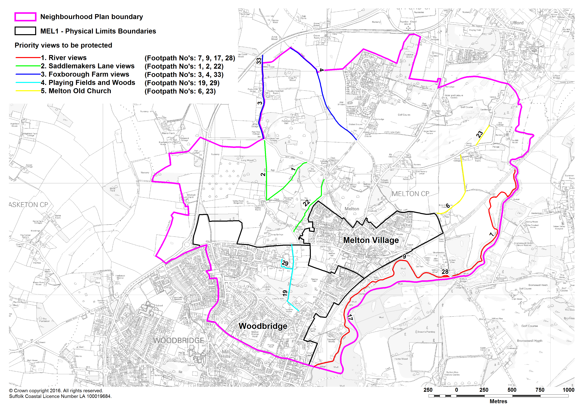
Appendix B: Proposed Village Hall plans and cost estimate which was subject to public consultation
See separate attachments:
- ‘Appendix B - Village Hall 3772-SK1-Site plan and plans’
- ‘Appendix B - Village Hall 3772-SK7-Plans’
- ‘Appendix B - Village Hall Order of Cost Estimate 02 02 17A RS’

Appendix C: Plans showing possible layouts of development of the Wilford Bridge Road site
See separate attachments:
- ‘Appendix C - 1724 Gridlestone Carter Warburg site diagram - May 2016’
- ‘Appendix C - 1724 Gridlestone Carter Warburg site sketch - Mar 2016 B copy’

Appendix D: Burke’s Wood – proposed area to be designated as Local Green Space and justification
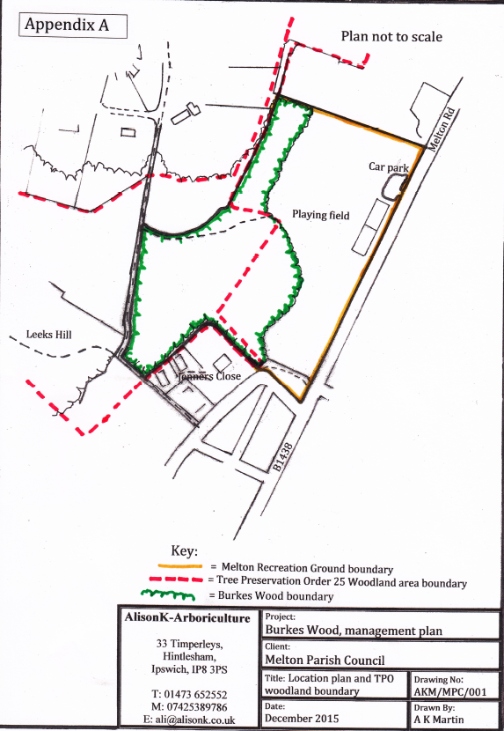

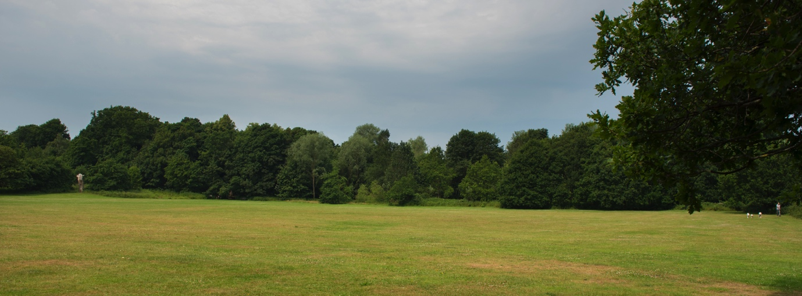
Burkes Wood is owned by Melton Parish Council and forms part of a larger mixed woodland which also includes Leeks Hill woods (owned by SCDC) and a privately owned area.
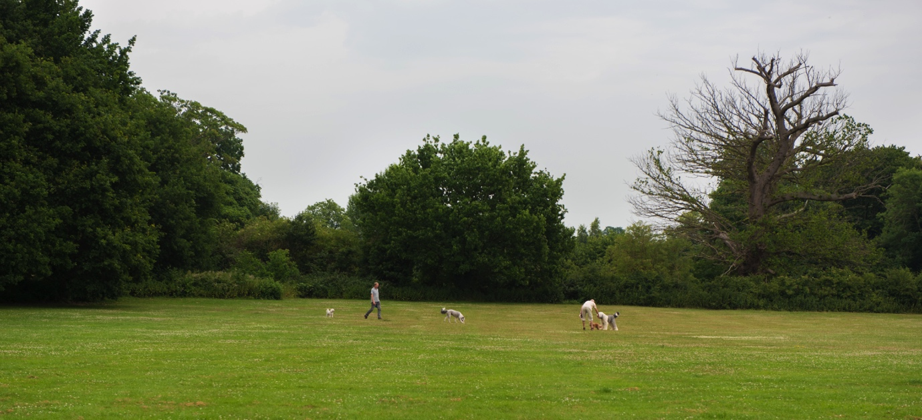
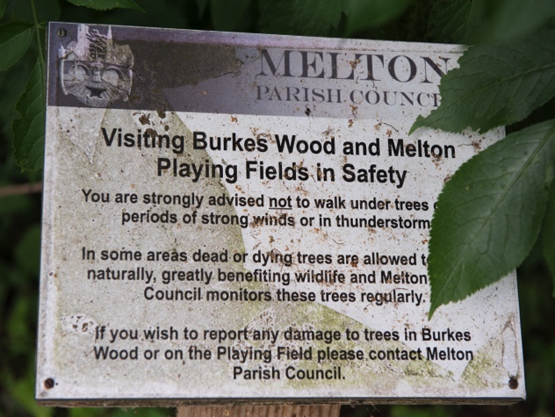
It is partly covered by a tree preservation order and forms a backdrop to Melton Playing Field.
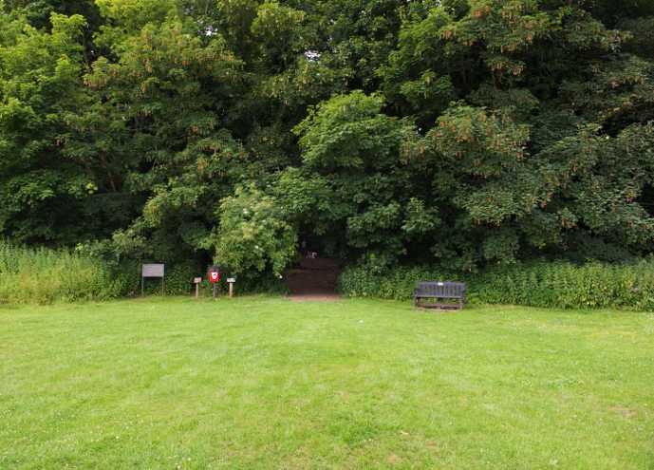
As well as being a well-used amenity for the community, it is an important wild-life habitat and contains a rich variety of flora.

A number of unofficial footpaths have been developed and these are used almost constantly by people taking exercise and dog walkers as well as being a through-route from the Melton Grange Estate to Melton Road.

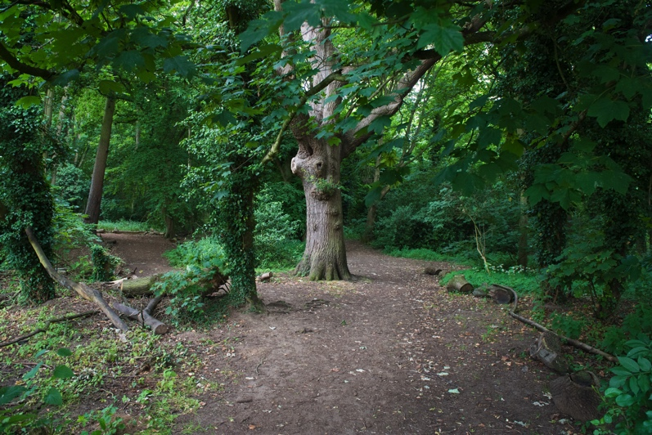
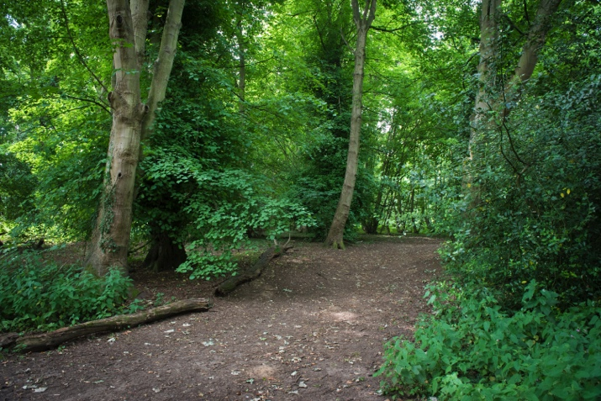

Over many years, trees have been lost and little replanting has taken place. This, plus wear on the paths has resulting in a loss of habitat, most notably for nightingales.

In 2016, the Parish Council commissioned a Management Plan for Burkes Wood with the intention of restoring the habitat while retaining the amenity for the community.

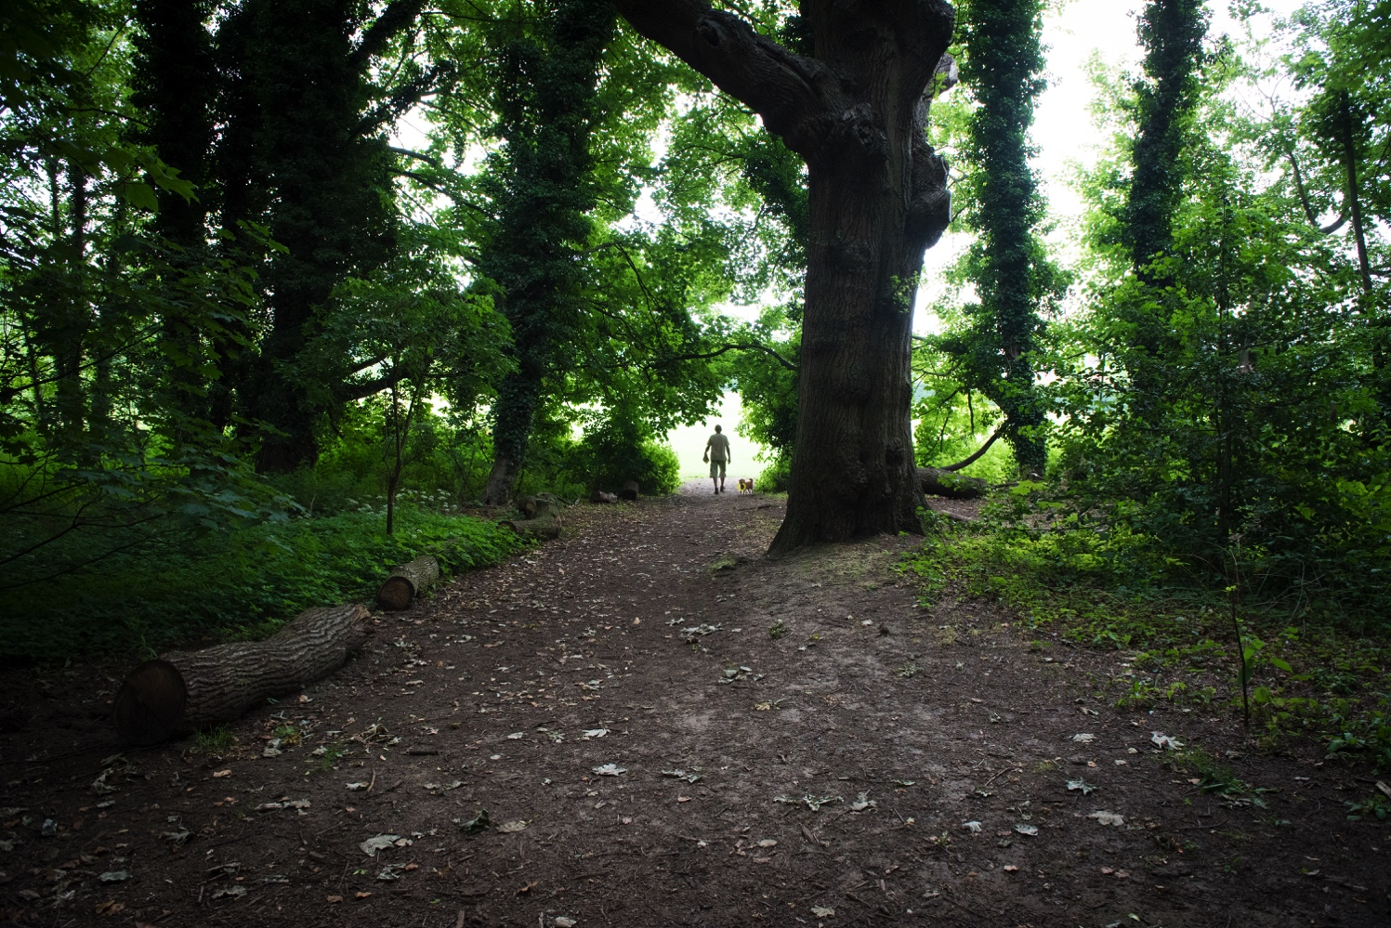
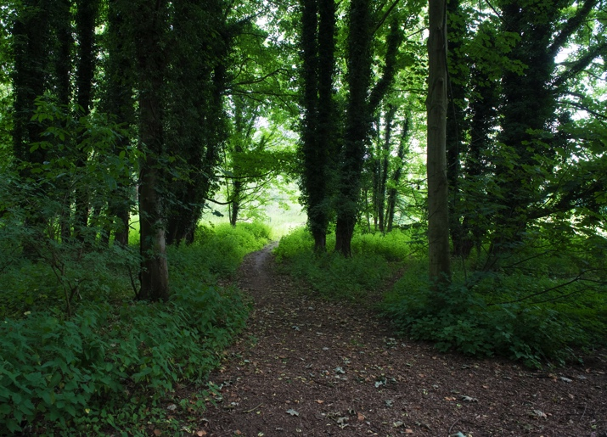

Over the next five years, it is hoped to remove dead and damaged branches and trees and do some replanting. Also to lift the canopy in some area so that the underlayer can be restored providing nesting areas.

Burkes Wood is a very valuable part of the Melton Playing Field area which forms a major ‘green lung’ within the village centre. Melton residents use it throughout the year for peace and quiet, exercise, dog walking, bird watching, access to residential areas, picnics and school outings, esp. for local nurseries.

Appendix E: Letter from promoter of Wilford Bridge Road allocation

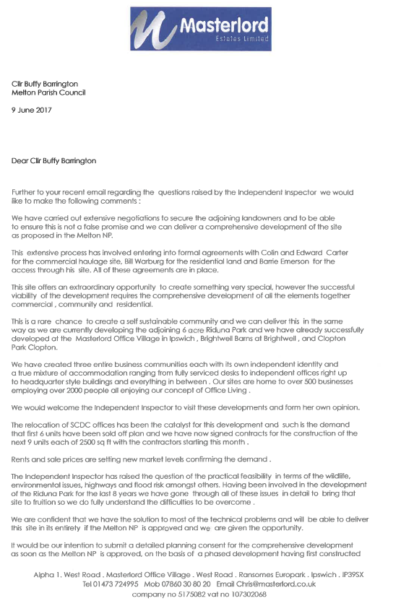

Based on our response to Q1, this requirement for 10 dwellings could increase by a further 19 dwellings to allow for the Neighbourhood Plan period running beyond the Local Plan period by three years. This would increase the requirement to 29 dwellings.

