Melton Neighbourhood Plan
Business Questionnaire Analysis

111 Businesses were found and contacted in Melton. We wrote to each one and asked if they would fill in the Business Questionnaire online which they could access through the website.

17 businesses responded.

This gives us a 15% response rate overall.

The businesses were:

Arkray Factory Ltd

DEBEN INNS LTD

EDUFOCUS LIMITED

Hopkins Homes Ltd

Infotex UK Ltd

Keystone IMC Ltd

Margary & Miller

Melton Primary School

Pitstop Out of School Club

Polestar (Woodbridge) Ltd.

REACT Computer Partnership

Rectory Garden Montessori School

Safetyboss

Springside shop

St.Audry's Golf Club

Ufford Park Woodbridge, Hotel Golf & Spa

Woodbridge Self Storage

Other premises:
Old Church Road, Hall Farm Road and Yarmouth Road

How many of your Employees live in Melton or Woodbridge?

What type of premises would your business require?

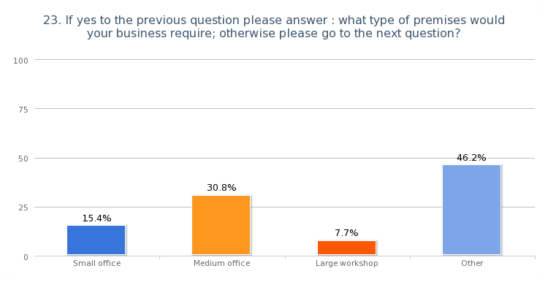

Other:
- Extension
- Medium sized building plus land for outdoor activities
- An increase in the Schools capacity would trigger an expansion of the premises
- Extend on existing sites
- Warehouse

What skills do you require?

- Montessori qualified teachers
- Solicitors specialising in Trust work and related topics

If you had problems filling job vacancies in the last 12 months why was it?
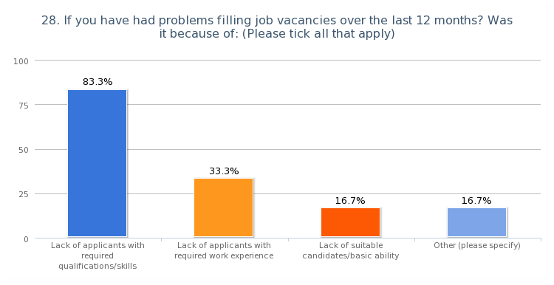

How do you Advertise your Job Vacancies?
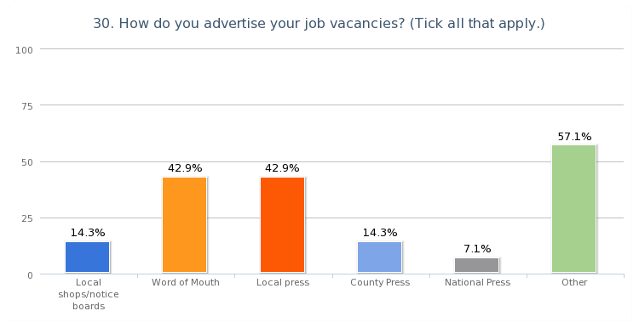

Other:
- Agencies
- Recruitment Agencies
- Specialist Agencies
- Specialist publications
- Suffolk County Council jobs site
- We are regularly approached by individuals who are seeking work
- Web Site

How do you rate the following local Services in Melton?

The only services to get a fairly high rating of ‘Average’ or ‘Poor’ were Mobile Phone signals and Public Transport.

How do you rate the following public services in Melton?

How do the following effect the smooth running of your Business?

Other Comments:

- Our business is self contained hence the only issue is directing visitors.
- The building works in Old Maltings approach can be disruptive at times
- The biggest problem we incur is the traffic lights in Melton Street from Ufford to Woodbridge. Often long delays.
- Access to site in Dock Lane can sometimes be restricted by cars in Dock Lane-some from residential, some from businesses and some from School
- Traffic congestion at the traffic lights can result in delays in picking up children from school. To explain - we collect children from 7 local schools and staff often collect from more than one school e.g. Eyke at 3.10pm then Woodbridge at 3.30pm.
- One of main advantages of being located on modern business park is availability of client parking on site and level access for wheelchair users and clients with limited mobility
- The smooth running of traffic locally is important for ease of access and customer perception of ease of access. We have parking on site so no problem there and signage and footfall are fine.
- All seems quite in order, the visual impact of A board advertising is sometimes off putting and dangerous when restricting views from cars.
- Parking is always an issue around the school in the mornings and afternoons. The Coach and Horses Pub kindly allow parents to park in their car park however we still do have issues with cars that illegally parked
- Parking in the road leading to Deben Mill has been extremely dangerous until recent yellow lines put down - understand that these will be removed once the building work is complete. These should be retained to enable persons coming to the offices to get here safely.
- If working outside home/attending meetings and leaving home at peak times I often waste time sitting in traffic queues. At peak times, when the fish and chip shop is open or there is an event in the church, it is impossible to park near my home. This means that I may need to make several journeys to my car with boxes of papers etc. that I need to take with me.

What Other Facilities would improve the Day-to-Day running of your Business?

- Better roads in and out of Woodbridge and Melton
- Having a 30 mile an hour limit along Old Church Road as transport moves fast along this road.
- Improved road infrastructure, marketing and network opportunities.
- Mobile phone signals are the biggest problem.
- None
- Wi Fi & better mobile phone signals
- Marketing and Advertising signage
- The only thing that would help improve my business would be a bigger car park on Melton Playing Field to stop the constant bad parking in Melton road Stopping delivery to the shop and upsetting residents by parking on both sides of the road. The Recreation Committee should do more to stop all this bad parking with the car boot in the summer and the 2 football matches at the same time on Saturday in the winter. Parking facilities need to be improved on the field if the car boot and winter football are to continue It is getting dangerous!
- Nothing I can think off, but perhaps road verges maintained more efficiently would improve the visual appearance all round.
- Road infrastructure would help as long as children had a safe environment to walk to school. Increase in housing would of course allow for potentially more children to come to the school!

If new business developments were proposed in Melton how would this effect your own Business?

56% Positive

11% Negative

33% No Effect

Comments:
- We would welcome new business developments to enable expansion of the services we provide, which in turn would create additional employment opportunities. Current restrictions do little to help the viability of the business.
- It would depend on how they influenced traffic and whether any of the businesses were the same as ours.

What can your Business do to Engage with the Community?

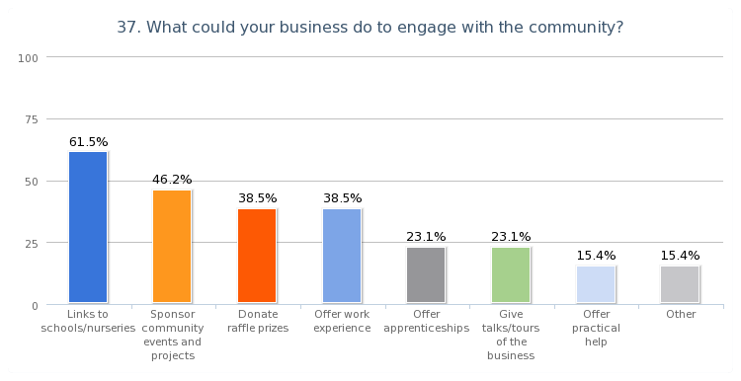
Other ways your Business can Engage with the Community?

- Access to all our facilities is readily available. We are very active in all local activities.
- We hope, in the future, to offer informal meetings to provide info. about older client issues. We have confidentiality issues, which make it difficult for us to offer work experience, particularly to young people. I’ve answered the questions on basis of Melton but we’re part of a larger group of offices where we do sponsor local events etc. Many of the questions aren't relevant to a small office like ours, which is part of a larger group. None of us reside in Melton but we all live within five miles.
- We supply and online service (EVOLVE) that enables schools (LA maintained, as well as independent) to safely and securely create, register and approve educational visits. We would happily demonstrate our services to schools n the local area that do not already use our system and could offer training to those that do.
- As a health and safety consultancy we could give practical advice and assistance for community projects etc. – we’d be prepared to assist in other projects involving the disadvantaged or elderly should the need arise.
- We’re currently looking for land to expand the business and create a community farm. Ideally we would like to do this in Melton as it’s been Pitstop's home since it started in 2003. The farm would encompass animals and horticulture, bring additional employment and training opportunities, as well as a local feature for the people of Melton to learn about the great outdoors. Our Business Plan on our new venture will be available in March and we would welcome the opportunity to discuss this further with the Parish Council.

